

# 

### Semester Two Examination, 2020

### Question/Answer booklet

# MATHEMATICS

**SOLUTIONS**

**SPECIALIST**

**UNITS 1&2**

## Section One:

## Calculator-free

|  |  |  |  |  |  |  |  |  |  |  |
| --- | --- | --- | --- | --- | --- | --- | --- | --- | --- | --- |
| WA student number: In figures |  |  |  |  |  |  |  |  |  |  |

In words

Your name

|  |  |
| --- | --- |
| Number of additional answer booklets used (if applicable): |  |

## Time allowed for this section

Reading time before commencing work: five minutes

Working time: fifty minutes

## Materials required/recommended for this section

***To be provided by the supervisor***

This Question/Answer booklet

Formula sheet

***To be provided by the candidate***

Standard items: pens (blue/black preferred), pencils (including coloured), sharpener,  
correction fluid/tape, eraser, ruler, highlighters

Special items: nil

## Important note to candidates

No other items may be taken into the examination room. It is **your** responsibility to ensure that you do not have any unauthorised material. If you have any unauthorised material with you, hand it to the supervisor **before** reading any further.

## Structure of this paper

|  |  |  |  |  |  |
| --- | --- | --- | --- | --- | --- |
| Section | Number of questions available | Number of questions to be answered | Working time (minutes) | Marks available | Percentage of examination |
| Section One: Calculator-free | 8 | 8 | 50 | 52 | 35 |
| Section Two: Calculator-assumed | 13 | 13 | 100 | 98 | 65 |
|  | | |  | **Total** | 100 |

## Instructions to candidates

1. The rules for the conduct of examinations are detailed in the school handbook. Sitting this examination implies that you agree to abide by these rules.

2. Write your answers in this Question/Answer booklet preferably using a blue/black pen.  
Do not use erasable or gel pens.

3. You must be careful to confine your answers to the specific question asked and to follow any instructions that are specific to a particular question.

4. Show all your working clearly. Your working should be in sufficient detail to allow your answers to be checked readily and for marks to be awarded for reasoning. Incorrect answers given without supporting reasoning cannot be allocated any marks. For any question or part question worth more than two marks, valid working or justification is required to receive full marks. If you repeat any question, ensure that you cancel the answer you do not wish to have marked.

5. It is recommended that you do not use pencil, except in diagrams.

6. Supplementary pages for planning/continuing your answers to questions are provided at the end of this Question/Answer booklet. If you use these pages to continue an answer, indicate at the original answer where the answer is continued, i.e. give the page number.

7. The Formula sheet is not to be handed in with your Question/Answer booklet.

Section One: Calculator-free 35% (52 Marks)

This section has**eight** questions. Answer **all** questions. Write your answers in the spaces provided.

Working time: 50 minutes.

Question 1 (7 marks)

Two matrices are $A=\left[\begin{matrix}-2 & 2 \\ -4 & 3\end{matrix}\right]$ and $B=\left[\begin{matrix}0 & -5 \\ 10 & 5\end{matrix}\right]$. Determine

|  |
| --- |
| **Solution** |
| $$3A-2B=\left[\begin{matrix}-6 & 6 \\ -12 & 9\end{matrix}\right]-\left[\begin{matrix}0 & -10 \\ 20 & 10\end{matrix}\right] \\ =\left[\begin{matrix}-6 & 16 \\ -32 & -1\end{matrix}\right]$$ |
| **Specific behaviours** |
| ✓ one correct multiple  ü correct matrix |

(a) $3A-2B$. (2 marks)

(b) $A^{-1}$. (2 marks)

|  |
| --- |
| **Solution** |
|  |
| **Specific behaviours** |
| ✓ determinant  ü correct matrix |

(c) $AB+B^{2}$. (3 marks)

|  |
| --- |
| **Alternative Solution** |
| $$AB=\left[\begin{matrix}20 & 20 \\ 30 & 35\end{matrix}\right] \\ B^{2}=\left[\begin{matrix}-50 & -25 \\ 50 & -25\end{matrix}\right] \\ AB+B^{2}=\left[\begin{matrix}-30 & -5 \\ 80 & 10\end{matrix}\right]$$ |
| **Specific behaviours** |
| ✓  ü $B^{2}$ ü correct matrix |

|  |
| --- |
| **Solution** |
| $$\left(A+B\right)×B=\left[\begin{matrix}-2 & -3 \\ 6 & 8\end{matrix}\right]×\left[\begin{matrix}0 & -5 \\ 10 & 5\end{matrix}\right] \\ =\left[\begin{matrix}-30 & -5 \\ 80 & 10\end{matrix}\right]$$ |
| **Specific behaviours** |
| ✓ factors  ü $A+B$ ü correct matrix |

Question 2 (6 marks)

(a) State the exact value of $\cot{60°}$. (1 mark)

|  |
| --- |
| **Solution** |
| $$\frac{1}{\tan{60°}}=\frac{1}{\sqrt{3}}=\frac{\sqrt{3}}{3}$$ |
| **Specific behaviours** |
| ✓ correct value |

(b) Given that $\sec{θ}=\begin{matrix}3 \\ \overline{2}\end{matrix}$ and $-90°≤θ≤0°$, state the exact value of $\operatorname{cosec}{θ}$. (2 marks)

|  |
| --- |
| **Solution** |
| $$\operatorname{cosec}{θ}=\frac{3}{-\sqrt{5}}=-\frac{3\sqrt{5}}{5}$$ |
| **Specific behaviours** |
| ✓ value is negative  ü correct value |

(c) Sketch the graph of $y=2\sec{x}$ for $0°≤x≤180°$ on the axes below. (3 marks)

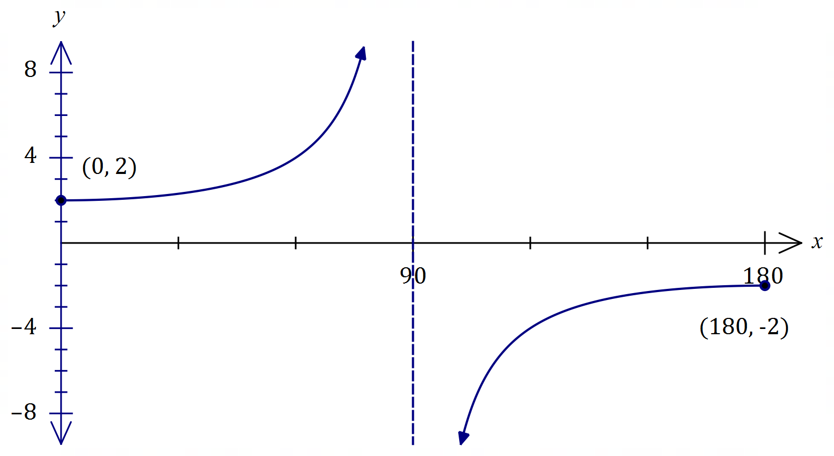

|  |
| --- |
| **Solution** |
| See graph |
| **Specific behaviours** |
| ✓ vertical asymptote  ü correct endpoints  ü smooth curves |

Question 3 (8 marks)

(a) Express ${\left(\sqrt{5}+\sqrt{-5}\right)}^{2}$ in the form $a+bi$ where $a, b∈R$. (2 marks)

|  |
| --- |
| **Solution** |
| $$\left(\sqrt{5}+\sqrt{-5}\right)\left(\sqrt{5}+\sqrt{-5}\right)=5+2\sqrt{5}\sqrt{5}i-5 \\ =10i$$ |
| **Specific behaviours** |
| ✓ uses $i^{2}=-1$ ü correctly simplifies |

(b) Two complex numbers are $u=8+i$ and $v=2-i$. Calculate

(i) $u×v$. (1 mark)

|  |
| --- |
| **Solution** |
| $$uv=(8+i)(2-i) \\ =17-6i$$ |
| **Specific behaviours** |
| ✓ correct product |

(ii) $u÷v$. (2 marks)

|  |
| --- |
| **Solution** |
| $$\frac{u}{v}=\frac{8+i}{2-i}×\frac{2+i}{2+i} \\ =\frac{15+10i}{5} \\ =3+2i$$ |
| **Specific behaviours** |
| ✓ correctly uses conjugate of $v$ ü correct quotient, simplified |

(iii) $\operatorname{Im}{(2\overline{v}-iu)}$. (3 marks)

|  |
| --- |
| **Solution** |
| $$2\overline{v}=2\left(2+i\right)=4+2i$$ $$iu=i\left(8+i\right)=-1+8i$$ $$2\overline{v}-iu=5-6i⇒\operatorname{Im}\left(2\overline{v}-iu\right)=-6$$ |
| **Specific behaviours** |
| ✓  ü product $iu$ ü imaginary part of difference |

Question 4 (7 marks)

(a) Use an angle sum identity to prove that $\tan{2A}=\begin{matrix}2\tan{A} \\ \overline{1-\tan^{2}{A}}\end{matrix}$. (2 marks)

|  |
| --- |
| **Solution** |
| $$\tan\left(A+A\right)=\frac{\tan{A}+\tan{A}}{1-\tan{A}\tan{A}} \\ \tan{2A}=\frac{2\tan{A}}{1-\tan^{2}{A}}$$ |
| **Specific behaviours** |
| ✓ uses angle sum identity  ü simplifies |

(b) Hence, or otherwise, prove that $\tan{3A}=\begin{matrix}3\tan{A}-\tan^{3}{A} \\ \overline{ 1-3\tan^{2}{A} }\end{matrix}$. (3 marks)

|  |
| --- |
| **Solution** |
| $$\tan\left(2A+A\right)=\frac{\tan{2A}+\tan{A}}{1-\tan{2A}\tan{A}} \\ \tan{3A}=\frac{\frac{2\tan{A}}{1-\tan^{2}{A}}+\tan{A}}{1-\frac{2\tan{A}}{1-\tan^{2}{A}}×\tan{A}} \\ =\frac{2\tan{A}+\tan{A}-\tan^{3}{A}}{1-\tan^{2}{A}-2\tan^{2}{A}} \\ =\frac{3\tan{A}-\tan^{3}{A}}{1-3\tan^{2}{A}}$$ |
| **Specific behaviours** |
| ✓ uses angle sum identity  ü uses double angle identity  ü simplifies |

(c) Solve $3\tan{A}-\tan^{3}{A}=1-3\tan^{2}{A}$ for $0°<A<30°$. (2 marks)

|  |
| --- |
| **Solution** |
| $$\frac{3\tan{A}-\tan^{3}{A}}{1-3\tan^{2}{A}}=1 \\ \tan{3A}=1 \\ A=15°$$ |
| **Specific behaviours** |
| ✓ writes equation using triple angle  ü correct solution |

Question 5 (5 marks)

$AC$ is a diameter of a circle centre $O$ and point $B$ lies on the circumference of the circle.  
  
Let $\vec{OA}=a$ and $\vec{OB}=b$.  
  
Use a vector method to prove that $∠ABC=90°$.

|  |
| --- |
| **Solution** |
| Hence $\vec{AB}$ and $\vec{CB}$ are perpendicular ($∠ABC=90°$) since their magnitudes are not zero yet the scalar product is zero. |
| **Specific behaviours** |
| ü labelled sketch  ✓ vectors $\vec{AB}$ and $\vec{CB}$ ü forms scalar product  ü simplifies  ü explains result |

Question 6 (6 marks)

(a) Determine the equation of the real quadratic $f(z)$ in the form $z^{2}+az+b$ given that $f\left(5-3i\right)=0$. (2 marks)

|  |
| --- |
| **Alternative Solution** |
| $$a=-2\left(5\right)=-10$$ $$b=5^{2}+3^{2}=34$$ $$f\left(z\right)=z^{2}-10z+34$$ |
| **Specific behaviours** |
| ✓ shows sum and product of roots  ü correct equation |

|  |
| --- |
| **Solution** |
| $$f\left(z\right)=\left(z-5+3i\right)\left(z-5-3i\right) \\ =z^{2}-10z+34$$ |
| **Specific behaviours** |
| ✓ shows product of linear factors  ü correct equation |

(b) Let $g\left(z\right)=z^{2}-8z+17$.

(i) Determine $z_{1}$ and $z_{2}$, the complex roots of $g$. (2 marks)

|  |
| --- |
| **Solution** |
| $${\left(z-4\right)}^{2}=-17+4^{2} \\ =-1=i^{2} \\ z=4±i$$ $$z_{1}=4+i, z_{2}=4-i$$ |
| **Specific behaviours** |
| ✓ indicates suitable method  ü correct conjugate roots |

(ii) Sketch and label $z_{1}$, $z_{2}$ and $w=z_{1}+z_{2}$ in the complex plane below. (2 marks)

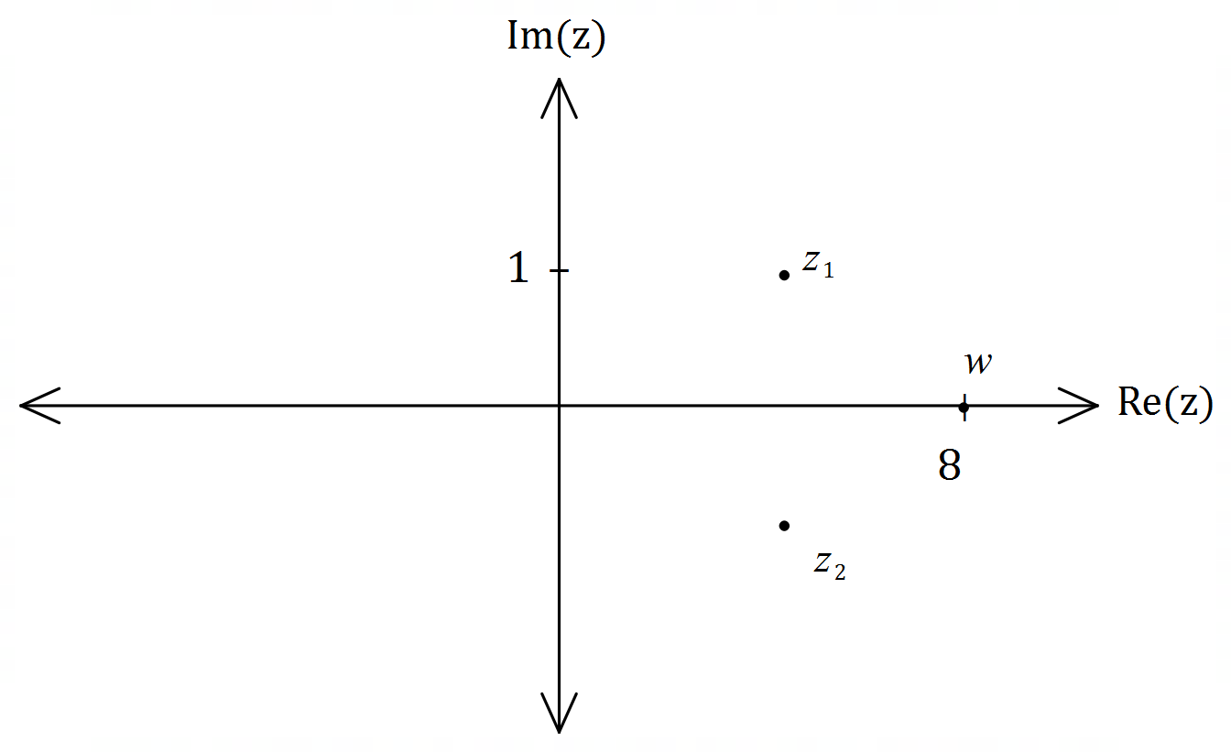

|  |
| --- |
| **Solution** |
| See graph (their $z_{1}$ and $z_{2}$) |
| **Specific behaviours** |
| ✓ roots clearly conjugate pair  ü scales axes and locates $w$ |

Question 7 (7 marks)

Use mathematical induction to prove the following proposition $P(n)$ for every integer $n≥0$.

$$P\left(n\right): 1+9+17+25+…+\left(8n+1\right)=(n+1)(4n+1)$$

|  |
| --- |
| **Solution** |
| 1. When $n=0$: $$P\left(0\right):8\left(0\right)+1=\left(0+1\right)\left(4\left(0\right)+1\right)→1=1, ∴\text{true}$$ 2. Assume $P(k)$ is true: $$1+9+…+\left(8k+1\right)=(k+1)(4k+1)$$ 3. Now required to prove $P(k+1)$: $$1+9+…+\left(8k+1\right)+\left(8\left(k+1\right)+1\right)=\left(\left(k+1\right)+1\right)\left(4\left(k+1\right)+1\right) \\ =(k+2)(4k+5)$$ From assumption: $$1+9+…+\left(8k+1\right)=(k+1)(4k+1)$$ Hence $$1+9+…+\left(8k+1\right)+\left(8\left(k+1\right)+1\right)=(k+1)(4k+1)+\left(8\left(k+1\right)+1\right) \\ =4k^{2}+5k+1+8k+9 \\ =4k^{2}+13k+10 \\ =(k+2)(4k+5)$$ Since $P(0)$ is true and we have shown that $P(k+1)$ is true if $P(k)$ is true then $P(n)$ is true for all integers $n≥0$. |
| **Specific behaviours** |
| ✓ shows true for $n=0$ ü states assumption that $P(k)$ is true  ü indicates expression required for $P(k+1)$ ü adds ${\left(k+1\right)}^{th}$ term to assumption  ü expands RHS  ü factors RHS  ü uses principle of mathematical induction |

Question 8 (6 marks)

(a) Determine the vector projection of $2i-j$ on $-3i+4j$. (2 marks)

|  |
| --- |
| **Solution** |
| $$\left(\frac{1}{5}\left(\begin{matrix}-3 \\ 4\end{matrix}\right)∙\left(\begin{matrix}2 \\ -1\end{matrix}\right)\right)\frac{1}{5}\left(\begin{matrix}-3 \\ 4\end{matrix}\right)=\frac{-10}{25}\left(\begin{matrix}-3 \\ 4\end{matrix}\right) \\ =\left(\begin{matrix}6/5 \\ -8/5\end{matrix}\right)$$ |
| **Specific behaviours** |
| ✓ indicates method  ü correct projection |

|  |
| --- |
| **Alternative Solution** |
| $$\frac{\left(\begin{matrix}2 \\ -1\end{matrix}\right)∙\left(\begin{matrix}-3 \\ 4\end{matrix}\right)}{\left(\begin{matrix}-3 \\ 4\end{matrix}\right)∙\left(\begin{matrix}-3 \\ 4\end{matrix}\right)}\left(\begin{matrix}-3 \\ 4\end{matrix}\right)=\frac{-10}{25}\left(\begin{matrix}-3 \\ 4\end{matrix}\right) \\ =\left(\begin{matrix}6/5 \\ -8/5\end{matrix}\right)$$ |
| **Specific behaviours** |
| ✓ indicates method  ü correct projection |

(b) The vectors $ai+j$ and $4i+bj$ are perpendicular and the sum of their magnitudes is $10$. Determine the values of the constants $a$ and $b$. (4 marks)

|  |
| --- |
| **Solution** |
| Perpendicular: $4a+b=0$.  Magnitudes: $\sqrt{a^{2}+1}+\sqrt{{16+b}^{2}}=10$.  Hence $$b=-4a⇒b^{2}=16a^{2} \\ \sqrt{a^{2}+1}+\sqrt{{16+16a}^{2}}=10 \\ \sqrt{a^{2}+1}+4\sqrt{a^{2}+1}=10 \\ \sqrt{a^{2}+1}=2 \\ a^{2}=3⇒a=±\sqrt{3} \\ b=∓4\sqrt{3}$$ Hence $a=\sqrt{3}, b=-4\sqrt{3}$ or $a=-\sqrt{3}, b=4\sqrt{3}$. |
| **Specific behaviours** |
| ✓ two equations  ü eliminates one variable  ü solves for one variable  ü clearly states both solutions |

Supplementary page

Question number: _________

© 2020 WA Exam Papers. Kennedy Baptist College has a non-exclusive licence to copy and communicate this document for non-commercial, educational use within the school. No other copying, communication or use is permitted without the express written permission of WA Exam Papers. SN245-161-3.